# Tool Development NES game design idea

**Potential Names**

* Notcurne’s Blood
* Shadowwake
* Deadlight
* Soul Hex
* DreadVale

**The feel**

Idea of the game is to be a 2d Sidescroller metroidvania, to feel like a journey of discovery as the character travels through a village and dungeons to release themselves from the spell they have been under. The character awakes in one of the huts in the village with no memory of what has happened, the character needs to traverse the village and dungeons to discover where they came from, who they are and how to undo the spell so they can finally return home.

**Inspiration**

Castlevania, I want it to feel grim and dark with monsters in the world that the character instinctually needs to defeat.

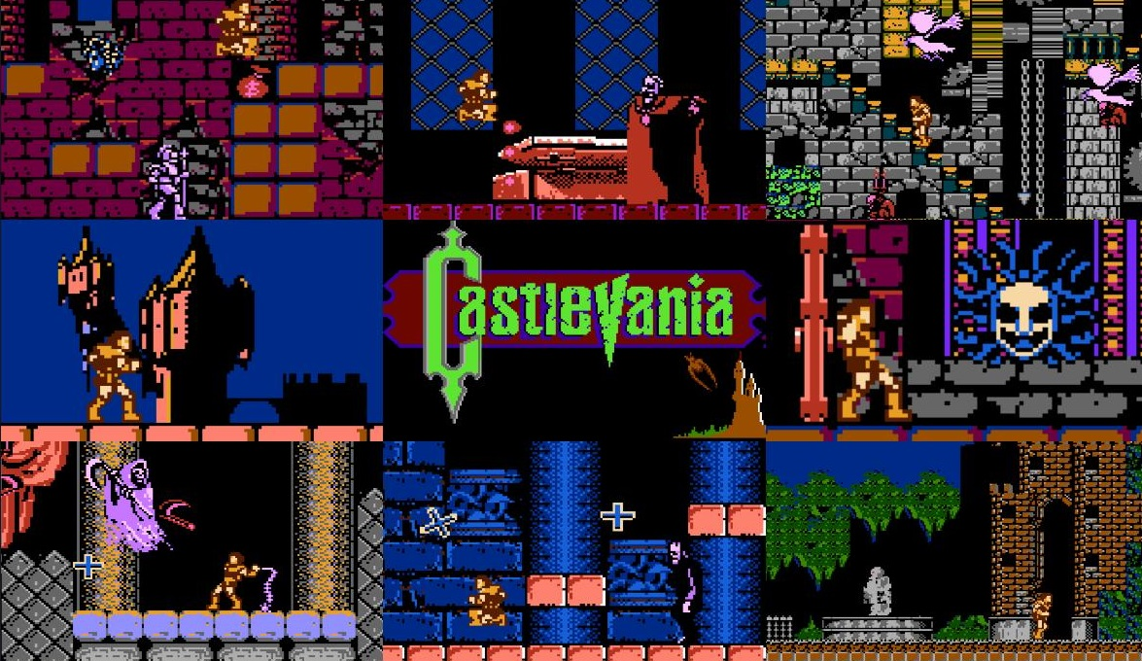

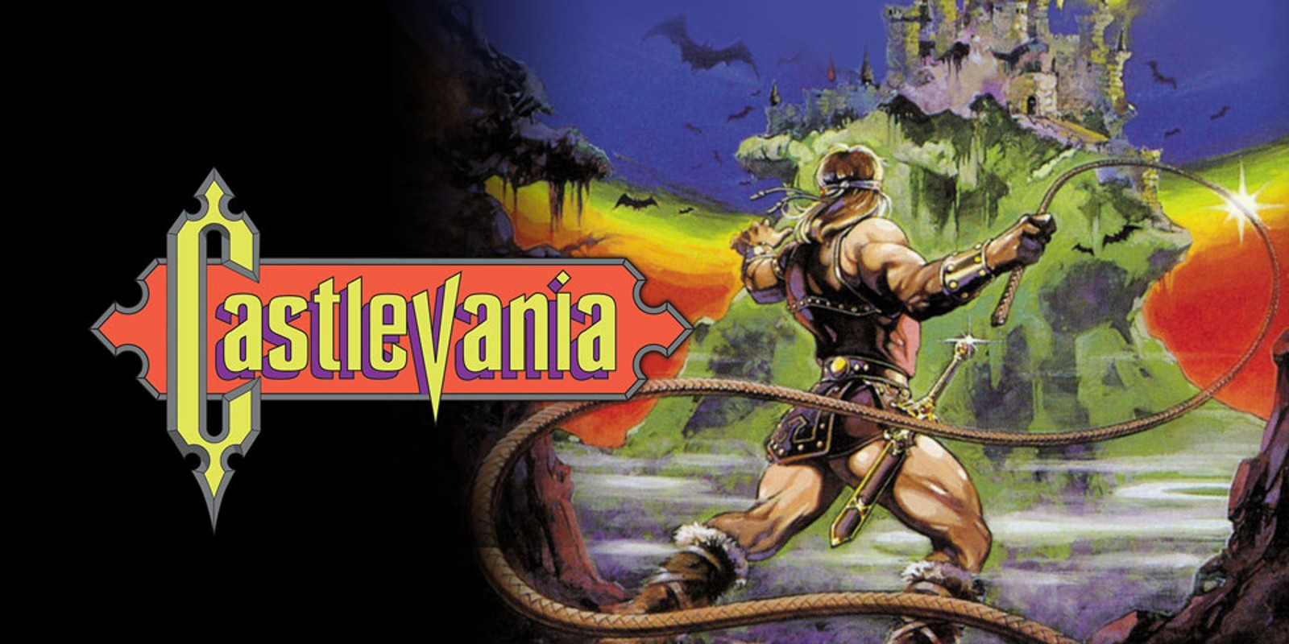

Metroid, for the character to feel like they’re the only person like them in the world, everything else is something they don’t recognise and there are no friends that they can just rely on. There are not any NPCs, only enemies, want the player to feel everything is against them and they are battling against all odds to survive and escape.

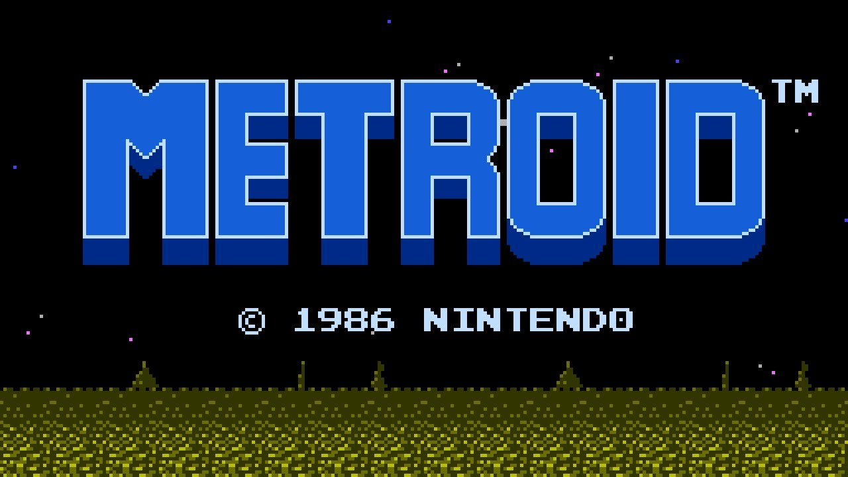

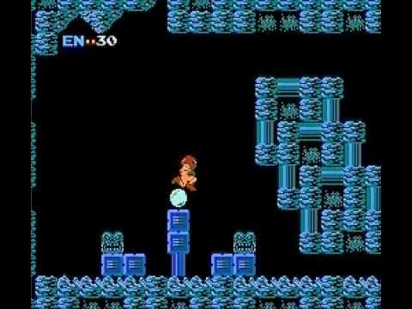

I want the game to have like UI of the legacy of the wizard, so the player understands how they are doing and whether they need to be more careful around enemies and what items they have on them. With the player forgetting their memories I don’t want the player to be completely useless.

